http://www.tecmint.com/check-linux-hard-disk-bad-sectors-bad-blocks/

How to Check Bad Sectors or Bad Blocks on Hard Disk in Linux

Let us start by defining a bad sector/block, it’s a section on a disk drive or flash memory that can not be read from or written to anymore, as a result of a fixed physical damage on the disk surface or failed flash memory transistors.
As bad sectors continue to accumulate, they can undesirably or destructively affect your disk drive or flash memory capacity or even lead to a possible hardware failure.
It is also important to note that the presence of bad blocks should alert you to start thinking of getting a new disk drive or simply mark the bad blocks as unusable.
Therefore, in this article, we will go through the necessary steps that can enable you determine the presence or absence of bad sectors on your Linux disk drive or flash memory using certain disk scanning utilities.
That said, below are the methods:

Check Bad Sectors in Linux Disks Using badblocks Tool
A badblocks program enables users to scan a device for bad sectors or blocks. The device can be a hard disk or an external disk drive, represented by a file such as /dev/sdc.
Firstly, use the fdisk command with superuser privileges to display information about all your disk drives or flash memory plus their partitions:
$ sudo fdisk -l
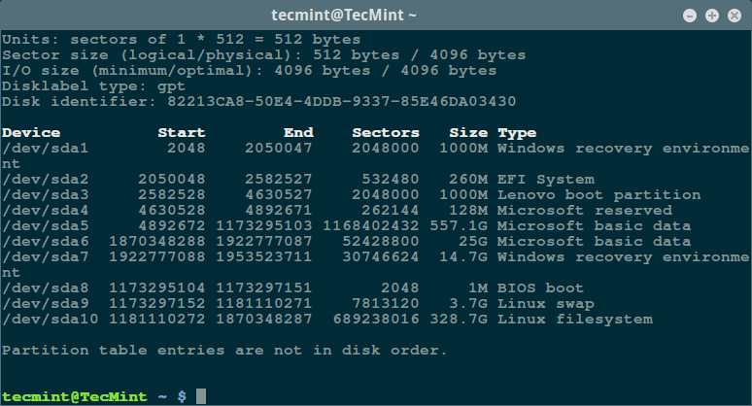
List Linux Filesystem Partitions
Then scan your Linux disk drive to check for bad sectors/blocks by typing:
$ sudo badblocks -v /dev/sda10 > badsectors.txt
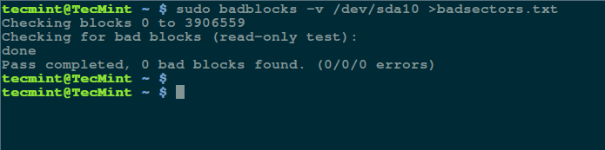
Scan Hard Disk Bad Sectors in Linux
In the command above, badblocks is scanning device /dev/sda10 (remember to specify your actual device) with the -v enabling it to display details of the operation. In addition, the results of the operation are stored in the file badsectors.txt by means of output redirection.
In case you discover any bad sectors on your disk drive, unmount the disk and instruct the operating system not to write to the reported sectors as follows.
You will need to employ e2fsck (for ext2/ext3/ext4 file systems) or fsck command with the badsectors.txt file and the device file as in the command below.
The -l option tells the command to add the block numbers listed in the file specified by filename (badsectors.txt) to the list of bad blocks.
------------ Specifically for ext2/ext3/ext4 file-systems ------------
$ sudo e2fsck -l badsectors.txt /dev/sda10
OR
------------ For other file-systems ------------
$ sudo fsck -l badsectors.txt /dev/sda10

Scan Bad Sectors on Linux Disk Using Smartmontools
This method is more reliable and efficient for modern disks (ATA/SATA and SCSI/SAS hard drives and solid-state drives) which ship in with a S.M.A.R.T (Self-Monitoring, Analysis and Reporting Technology) system that helps detect, report and possibly log their health status, so that you can figure out any impending hardware failures.
You can install smartmontools by running the command below:
------------ On Debian/Ubuntu based systems ------------
$ sudo apt-get install smartmontools
------------ On RHEL/CentOS based systems ------------
$ sudo yum install smartmontools
Once the installation is complete, use smartctl which controls the S.M.A.R.T system integrated into a disk. You can look through its man page or help page as follows:
$ man smartctl
$ smartctl -h
Now execute the smartctrl command and name your specific device as an argument as in the following command, the flag -H or --health is included to display the SMART overall health self-assessment test result.
$ sudo smartctl -H /dev/sda10
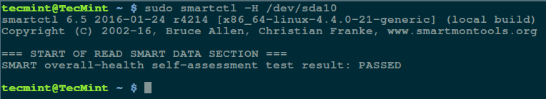
Check Linux Hard Disk Health
The result above indicates that your hard disk is healthy, and may not experience hardware failures any soon.
For an overview of disk information, use the -a or --all option to print out all SMART information concerning a disk and -x or --xall which displays all SMART and non-SMART information about a disk.
In this tutorial, we covered a very important topic concerning disk drive health diagnostics, you can reach us via the feedback section below to share your thoughts or ask any questions and remember to always stay connected to Tecmint.

#
# 20171102
#
https://www.smartmontools.org/wiki/Supported_RAID-Controllers

Checking disks behind RAID controllers
RAID controllers typically simulate a (logical) disk for each array of (physical) disks to the OS. Access to SMART functionality relies on ATA or SCSI pass through I/O controls providing direct access to each physical disk. But the standard I/O controls available are usually not designed to make this distinction between logical and physical disks. Therefore, smartmontools has to use vendor specific I/O controls. Support for disks behind RAID controllers is highly dependent on both platform and controller type.
RAID-Controller | Linux | FreeBSD | NetBSD | OpenBSD | MacOS | Solaris | Windows
LSI 3ware SATA RAID controller | -d 3ware,N /dev/twX ^{1.} | -d 3ware,N /dev/twX ^{2.} | - | - | - | - | /dev/sdX,N ^{3.}
Areca SATA[/SAS] RAID controller | -d areca,N[/E] /dev/sgX ^{4.} | -d areca,N[/E] /dev/arcmsrX ^{11.} | - | - | - | - | -d areca,N[/E] /dev/arcmsrX ^{12.}
HighPoint RocketRAID SATA RAID controller | -d hpt,L/M/N /dev/sdX ^{5.} | -d hpt,L/M/N /dev/hptX ^{6.} | - | - | - | - | -
CCISS (HP/Compaq Smart Array Controller) | -d cciss,N /dev/cciss/cXd0 ^{7.} | -d cciss,N /dev/cissX | - | - | - | - | -
LSI MegaRAID SAS RAID controller  Dell PERC 5/i,6/i controller | -d megaraid,N /dev/sdX ^{8.} | /dev/passX ^{9.} | - | - | - | - | /dev/csmiX,N ^{13.}
Intel ICHxR RAID  (Intel Rapid/Matrix Storage) | /dev/sdX | /dev/adX | ? | ? | ? | ? | /dev/csmiX,N ^{10.}
Adaptec SAS RAID controller  (devices supported by ​aacraid driver) | -d aacraid,H,L,ID /dev/sdX^{14.} | - | - | - | - | - | -d aacraid,H,L,ID /dev/sdX^{15.}
See the notes below and the INSTALL​ file for information about kernel and driver requirements on your platform. Also consult the man pages for controller specific smartmontools options or directives.

Notes:
1. 3ware RAID controllers are supported on Linux since smartmontools release 5.1-18. Support for char devices /dev/twX was added in release 5.33.
2. 3ware support on FreeBSD is available since release 5.33, multiple controller and char device support was added in release 5.36.
3. 3ware 9000 series only (added in release 5.37), requires Windows driver 9.4.0 or later. For older controllers, smartctl and smartd provide limited SMART support through tw_cli tool, see man page. Initially the SMART support was added only to the 32-bit Windows driver. With recent driver versions SMART access works on 64-bit Windows 7 (see ​mailing list) but not on 64-bit XP/2003 (see ticket #172).
4. Areca SATA controller support for Linux was added in release 5.39. Areca SAS controller support (SATA drives only) was added in release 5.43. SAS drive support was added in release 6.1.
5. HighPoint RocketRAID support for Linux was added in release 5.37.
6. HighPoint RocketRAID support for FreeBSD was added in release 5.39.
7. CCISS (Compaq Smart Array Controller) support for Linux was added in release 5.37. SATA auto-detection was added in release 5.43.
8. Support for LSI MegaRAID controller on Linux was added in release 5.39. Please note that on some controllers device enumeration starts from 8 (use -d megaraid,8 in such cases). In release 6.1 autoscan functionality implemented for the Linux version.
9. Support of LSI MegaRAID on FreeBSD is implemented with mfip.ko module and /dev/passX devices.
10. Intel ICHxR RAID (CSMI) support for Windows was added in release 5.41. May also work with other controllers if the driver implements CSMI.
11. Areca SATA controller support for FreeBSD was added in release 5.42. Areca SAS controller support (SATA drives only) was added in release 5.43. SAS drive support was added in release 6.1.
12. Areca SATA/SAS controller support (SATA drives only) for Windows was added in release 5.43. SAS drive support was added in release 6.0.
13. According to user reports, some Windows drivers for LSI MegaRAID and Dell PERC 6 implement CMSI (see ticket #243 and ​drive-database mailing list), other drivers don't (see ​support mailing list).
14. Aacraid support for Linux was added in release 6.3.
15. Adaptec support for Windows was added in release 6.4.

